|  |
| --- |
| **Specialization in Image Processing** |

** DEPARTMENT OF COMPUTER SCIENCE AND ENGINEERING**

**Approved by AICTE, New Delhi & Affiliated to JNTUH, Hyderabad**

**Accredited by NBA & NAAC, an ISO 9001:2015 Certified Institution**

**Shaikpet, Hyderabad-500104**

**G. Narayanamma Institute of Technology & Science (For Women) (Autonomous)**

**(Autonomous) (For Women)**

**GNR- 18 (2022 - 2023) IV B.Tech I Sem Major Project Phase- 1**

on “**Water Quality Monitoring using Image Processing and Neutral Networks**”

Under the guidance of

Mrs. Jayashree S Patil, Associate Professor

**Abstract**

The water quality, contaminant migration characteristics, and emissions quantity of pollutants in the basin would have a great impact on aquatic creatures, agricultural irrigation, human life, and so on. In the aquaculture industry, because water colour can reflect the species and number of phytoplankton in the water, the water quality type can be obtained by analysing the colour of the aquaculture water using image processing techniques.

Therefore, the aim is to propose an intelligent monitoring approach for water quality. The critical features of water colour images are extracted, and then using the machine learning methods, an intelligent system for water quality monitoring is to be established based on the fused random vector functional link network RVFL(randomised version of feedforward neural network) and group method of data handling GMDH(the core algorithm of selforganising data mining) model. The available techniques will be analyzed under their characterization, advancements and benefits in the assessment of the levels of wastewater contamination and identifying the contaminants. It also outlines the primary global wastewater quality parameters that need to be controlled and monitored for any wastewater produced as a result of human activities

**H/W & S/W Requirements**

S/W - Jupiter Notebook, MATLAB, Python, Tensor flow

H/W - Intel® Core™ i7-8565U, 908GB disc capacity, 8GB Ram capacity

*Dept R&D: No *If no: GNITS

1.Student Photo

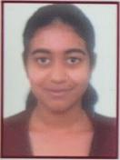

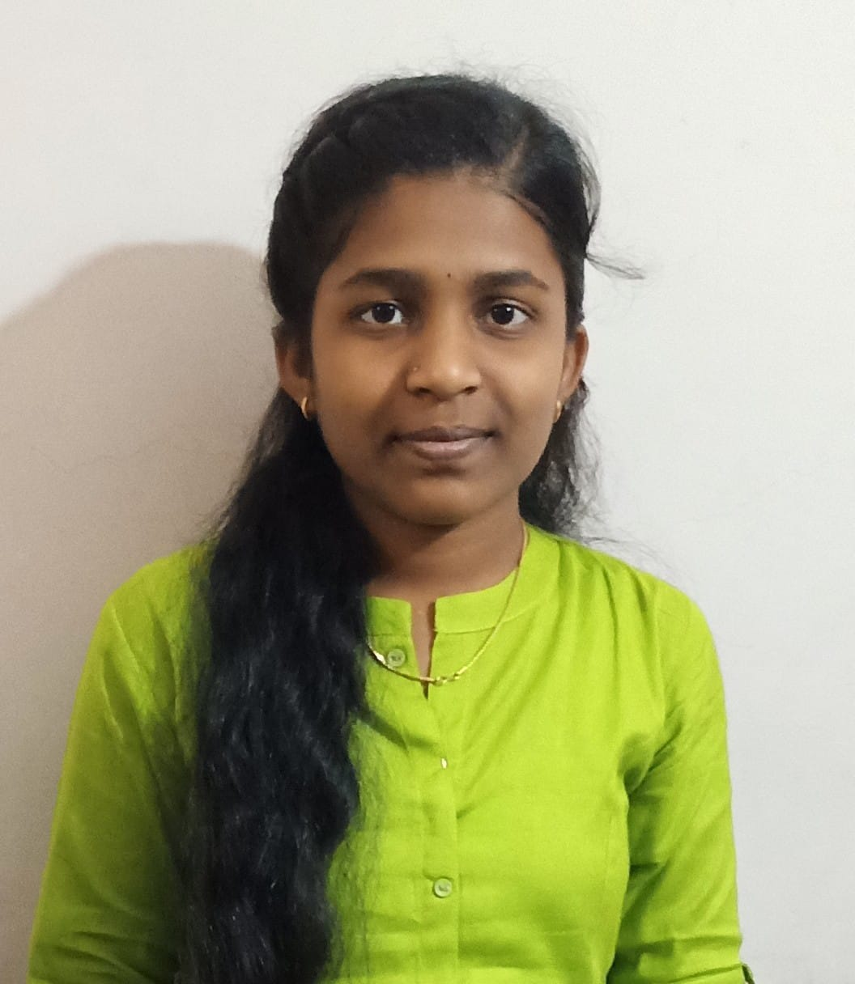2.Student Photo

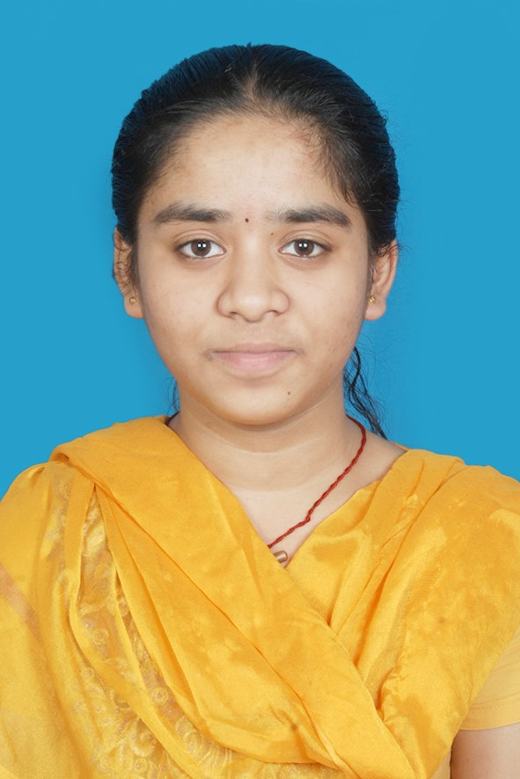3.Student Photo

19251A0501 19251A0538 19251A0551 19D21A05B3

1. Sai Sravya Akhila Mailaram B. Pavani Naga Kuamri Banvita Yadam

sravyaaman@gmail.com akhilamailaram0312@gmail.com [pavsai06.basa@gmail.com](mailto:pavsai06.basa@gmail.com) banvitayadam@gmail.com

**9676403416 7893022849 8008141872 6305740029**

**Internal Guide Class Coordinator Project Coordinator Head of Department**